
Learn360

Getting Started

Logging In

Navigating the site

Search

Browse

State Standards

Narrow Your Search

My Media Matches page

Playing Video

Full Screen Viewing

Playlists

Support

Log in to your account

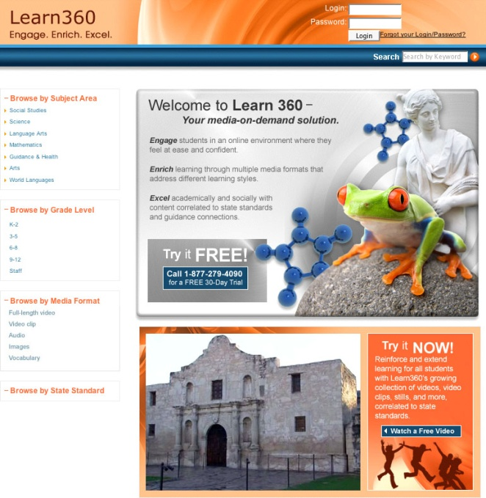
1. Enter your username and password in the fields located in the top, right-hand corner of the home page. Click the arrow, or press the Enter key on your keyboard.

2. Once you log in, you can search for video clips, full-length videos, audio clips, or images by entering keywords in the search box. You can also find media by browsing through subject areas, media formats, grade levels, or state standards, all located down the left-hand side of the page.

Don’t have an account or don’t know your login and password?

Contact the Atlantic County AVA for this information.

Navigating the Site
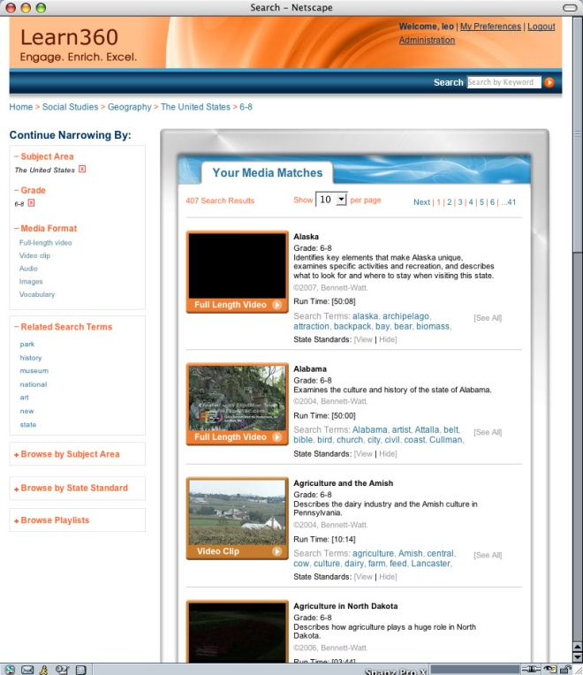

Breadcrumb trail
In the top left corner of your screen, directly below the logo and directly above the left-hand navigation sits the breadcrumb trail. It serves two primary purposes:

1. To see, at any point, where you are in the site.

2. To help you keep track of the path you have taken through the site.

Search

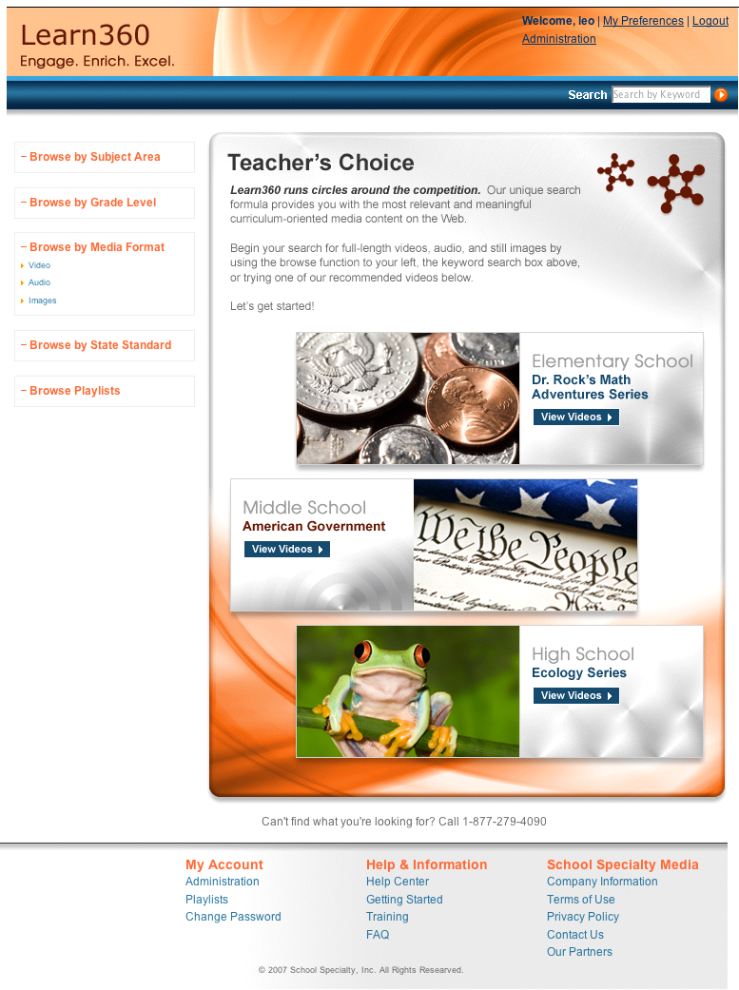
Keyword Search
Enter a keyword into the search box in the top right corner of any page and click the arrow button or hit Return. You can enter a single search term or a multi-word search term.
Example, you can enter the search for “equation” and receive a set of matches for this term. If you enter the search term “quadratic equations” you will receive a new, more targeted list of search results.

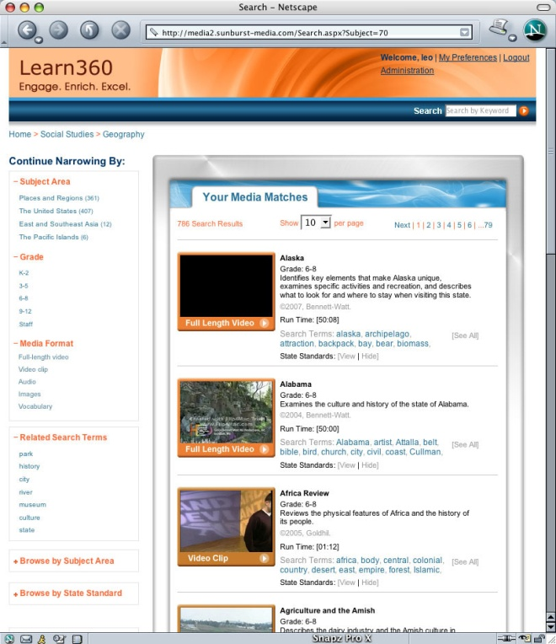
Browse
Users can browse by subject area, grade level, media type, and state standard, using the navigation tools on the left.

Browse by Subject Area
1. Choose a subject to Browse by and click on that subject.
2. You will immediately receive a list of subcategories.
3. Once you have chosen a subcategory, the engine will return a search result list for all the videos that are categorized under that subcategory.
3. From there, you can browse your results or continue to narrow your search results.
4. If you continue to narrow your search results you will be able to choose “Continue Narrowing By > Subject area”, choose a subcategory and then browse by topic area.

Example: If you choose Social Studies > Geography you will be able to continue to narrow your search by the subcategories under Geography:
* Places and Regions (361)
* The United States (407)
* East and Southeast Asia (12)
* The Pacific Islands (6)

The number in parentheses shows how many full-length videos, video and audio clips, and images are present in each subcategory.

5. Once you’ve chosen the category you wish to browse, you can continue to filter your results by grade level, or by media format.

Browse by Grade
1. Click a grade level to browse.
2. You will immediately receive a search result list for all the videos that are categorized under that grade level.
3. You can browse your results or continue to narrow your search results by subject area or by media format.

Browse by Media Format
1. Click a media format to browse. The media formats listed are full-length video, video clip, audio, images and vocabulary videos.
2. You will immediately receive a search result list for everything categorized under that media format.
3. You can browse your results or continue to narrow your search results by subject area, or by grade level.

Browse By State Standards
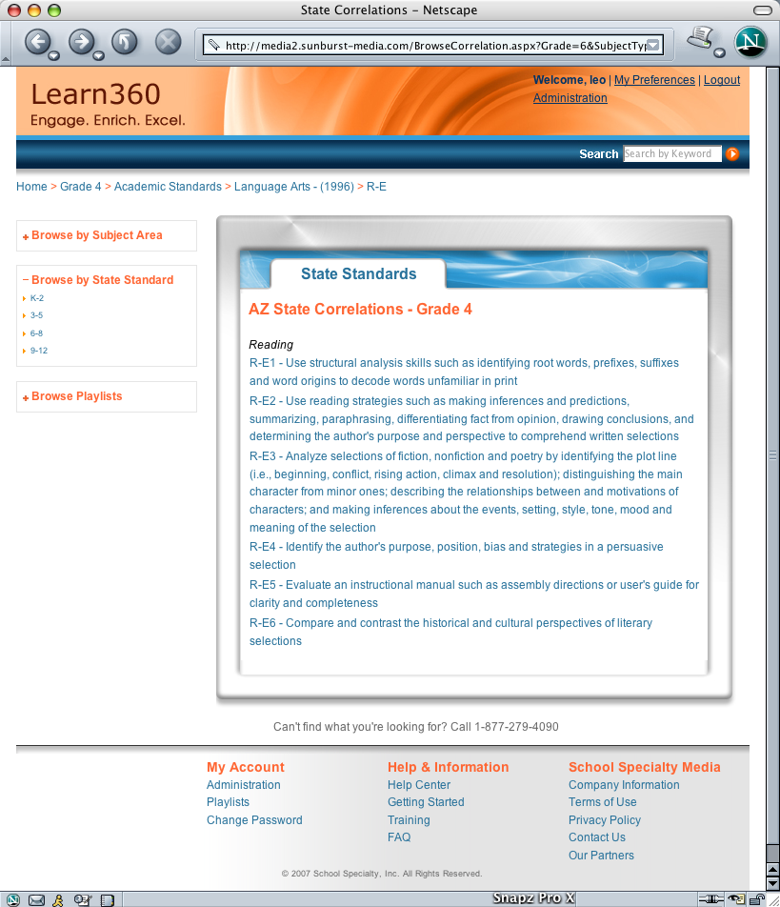
1. When your Site Administrator set up your account, your state standards were immediately applied to the site. When you select Browse by State Standard you will first be prompted to choose a grade band, then a specific grade by which to search the standards

2. Next, you will see the top level of the standards. Each choice will bring you to the next level of state standards. Once you have reached the deepest level you will be provided with a list of full-length videos and video clips that are aligned to that standard.

3. You can also find the state standards to which a particular clip is aligned on the media matches page. Under each search result, you have the ability to view the state standards that correlate to that video.

4. Additionally, on each player window page, you can view the state standards that correlate to the full-length video or video clip that you are currently watching. In the box to the right hand of the player window, there are three tabs: related media, activity, and State Standards. By clicking on the state standards tab, you will be able to see the state standard correlation for the video you are watching.

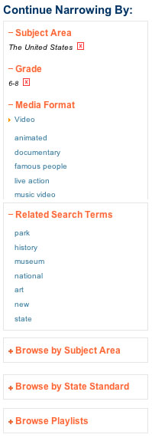
Continue Narrowing By
You can narrow your media matches with the features on the left hand side of the screen. Search results can be narrowed by subject area, grade level, and media format.

Once you have filtered your search in a specific category, a red “x” will appear next to the category. If you decide to change this category and choose again, click on the red “X” and the full list of filter choices for that category will reappear.
Once you have started to filter your search results, your filter options will remain present until you narrow them.

At any time, you are able to start a new search in three ways.
* Scroll down the page to Browse by Subject Area or State Standard.
* Use the breadcrumb and click on home or any place along the way you would like to go.
* Click on the logo which always brings you back to the home page.

Related Search terms
Any time you receive a list of media matches, whether it came from searching by keyword or by browsing, you will also receive a list of related search terms.

This list shows the top 7 search terms returned from your search and is an alternate way for users to browse the assets on Learn360.

Once you have received a set of results from your search or browse, click on any of these search terms to filter those results.

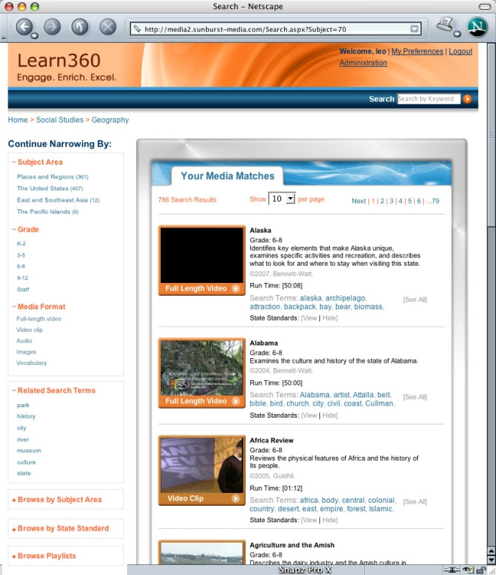

Media Matches page
Once you have chosen a keyword to search by or you are browsing you will receive a list of media assets that match your search/browse. From here you can choose how many results you would like to see per page; 10, 20, 30, or 50.

You can browse through all of the results or you can begin to narrow your search by subject area, grade level, or media format in the left navigation bar.

Once you have found the media asset you wish to view play by clicking on the title or on the words, “Play video” or “Play clip.”

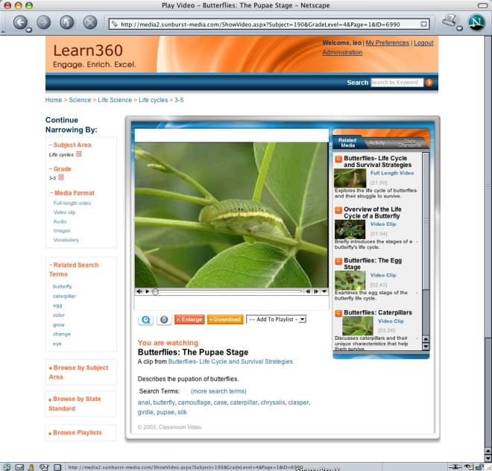
Playing Video

Player window page
Once you have clicked on a specific title of interest, simply click on the media player’s PLAY button and the media streams.
The media asset you chose to view will appear in the player window page. Your media type and the media player you will use to play your video is designated by your Administrator. However, if you wish to use a different media player to view videos, click one of the media player icons underneath the player window to make a change.

Below the player window you will be able to see the title of the clip you are watching, the title of the full-length video from which the video clip came, the grade level, publisher, and a short description of the video. Search terms are also listed.

To the right of the screen are related assets to help you get the most from the video you have chosen to view. Each asset has its own tab: Related Videos, Activities, State Standards.

1. Related videos. If you have chosen to view a full-length video, this section will list all of the segments of that clip. If you have chosen to view a video clip, this section lists the full-length video it came from and the other clips from that video.

2. Activity. A short activity to accompany the video clip you have chosen is reproduced here. Each activity was custom written for the clip that you have chosen. Each activity has an English/Language Arts emphasis and many have cross-curricular connections. Please note that some clips do not yet have activities. However, by January, all activities should be available.

3. State Standards. This tab lists the state standards that correlate to the clip/video that you are viewing.

Full Screen Viewing
Watch any Windows Media video in full screen by double clicking on the video.

The video will now expand to fill your entire computer screen. To exit from full screen mode, hit the Escape key on your keyboard.

Downloading Media
Download any media file (except National Geographic titles) to a local computer or server easily. To download a media file follow these step-by-step instructions:
1. Locate the Orange “Download” button underneath the media player.

2. Click on the Orange button to be taken to the download page.

3. You will be taken to a new page confirming the title you requested to download.

4. Using a PC:
• Right-click with your mouse on the link.
• From the pop-up menu, choose Save Target/Link As.
• Browse to the desired location on your local computer.
• Click “Save” to begin downloading.

Using a Mac:
• Hold down the Control key and click the link.
• From the pop-up menu, choose Download Linked File.
• The file will begin downloading.

Note: some media files may be restricted from downloading in some or all formats due to licensing restrictions.

Playlists

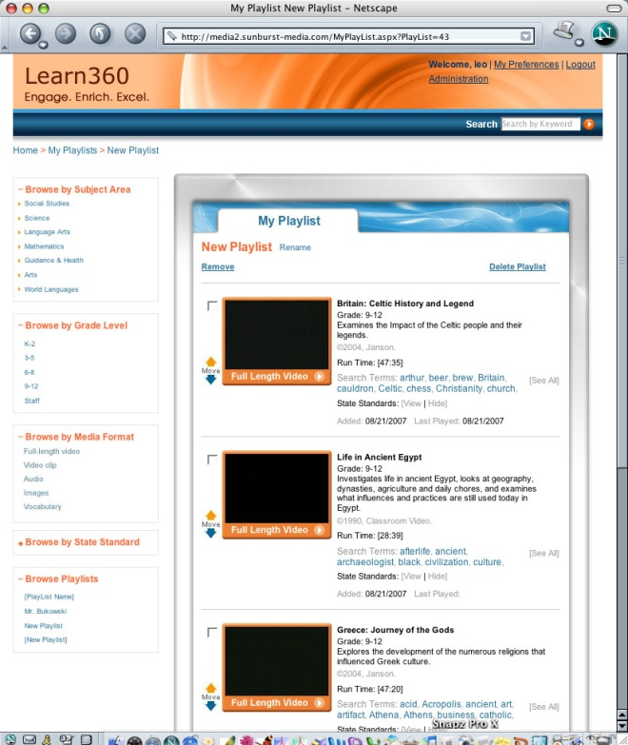
Playlists allow you to save your favorite media to a specific location; you can easily retrieve your playlists from any page using the Playlist link on the left-hand menu

Playlists can be accessed in two ways. You can browse preexisting playlists using your left-hand navigation. By selecting a preexisting playlist you can edit its name and add or delete titles.

You can also create a playlist while searching or browsing. If, as you watch a video or video clip, you want to add it to a playlist, use the drop-down menu at the bottom, right-hand side of your player window. You can add the video to an existing playlist or to a brand new playlist.

If you choose to add that asset to a new playlist, you will be brought to your playlist page and asked to save the playlist with a new name.

That playlist will then appear under the Browse by Playlist. You can continue to add new videos, audio clips, and images to that playlist.

An unlimited number of playlists can be created using all types of media on the site. Video playlists play files in sequential order. You can change the order of items in your playlist at any time.

Support Options

Call Technical Support
Learn360 experts can answer your questions, offer advice and solutions, and provide technical support. For assistance, please call 1-877-279-4090 between the hours of 7 A.M. and 5 P.M. ET.

E-mail Technical Support
The same level of support you receive via phone is also available through e-mail. For assistance, please send your e-mails to support@Learn360.com. E-mails are answered in the order in which they are received. A response is guaranteed within 24 hours.

Online Product Documentation
Additional detailed information, covering topics discussed in this guide can be found online in our Help Center.

Quick Start Guide
This guide will be available directly from the homepage to all first time users. Simply login to your account and the Quick Start guide link will appear in the top right-hand corner of the main page.

